A000-MEX-Mezcala, Guerrero-Figurine-Male-Serpentine-Early Preclassic-700-200 BCE

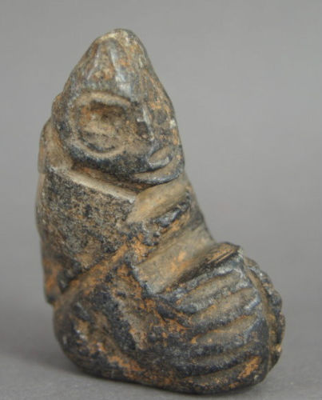 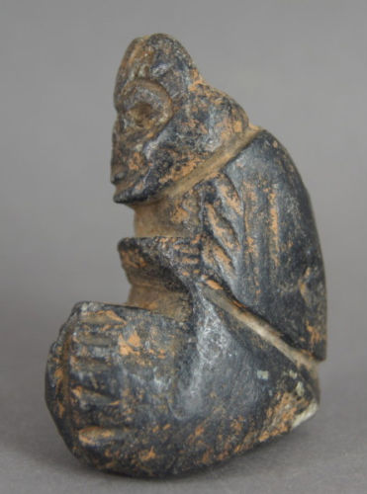 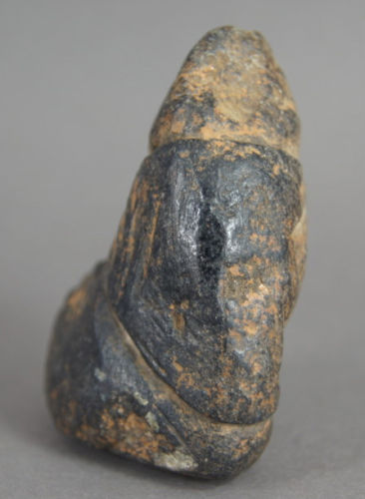 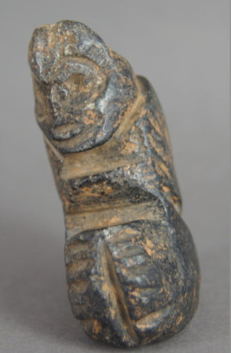

Figs. 1-4. Mezcala, Guerrero-Figurine-Male-Serpentine-Early Preclassic-700-200 BCE

Case no.:

Accession Number:

Formal Label: Mezcala, Guerrero-Figurine-Male-Serpentine-Early Preclassic-700-200 BCE

**Display Description:**

The Mezcala style was named by Miguel Covarrubias (1904-1957) who arranged small objects of polished stone, peculiar to the State of Guerrero in the form of figurines and masks, animal effigies and ornaments such as pearls, pendants or earrings (Covarrubias 1948, 1956, 1966: 106) into of five major groups of which the Mezcala figurine style was Type 5.

Type 1: Olmec or La Venta style (Chontal) Objects

Type 2: Olmec Style Objects

Type 3: Teotihuacan Style Objects

Type 4: Olmec-Teotihuacan Objects

Type 5: Local Style Objects-Mezcala, schematized pieces

The function of these figurines is hypothesized to be 1) tribute to fertility deities, 2) tribute to ancestors, and 3) consecration of habitations. These objects are grooved using what appears to have been an ax, with cuts and planes arranged geometrically and with facial or bodily features scarcely suggested. The raw material used is generally a hard stone (diorite, serpentine, andesite, marble and obsidian) the color of which varies from green to gray-green or gray. The Mezcala style is not limited to anthropomorphic representations but includes jaguars, frogs, monkeys, squirrel, birds, etc. Also included are miniature facades of temples, stone implements such as rectangular or triangular palettes and axes.

**LC Classification**:  [F1219.1.G93](http://luna.wellesley.edu/search~S1?/mF1219.1.G93+G29+1992/mf++1219.1+g93+g29+1992/-3,-1,,B/browse)

Date or Time Horizon: Early Preclassic, 700-200 BCE

Geographical Area: Balsas, Guerrero, Mexico

**Map:**

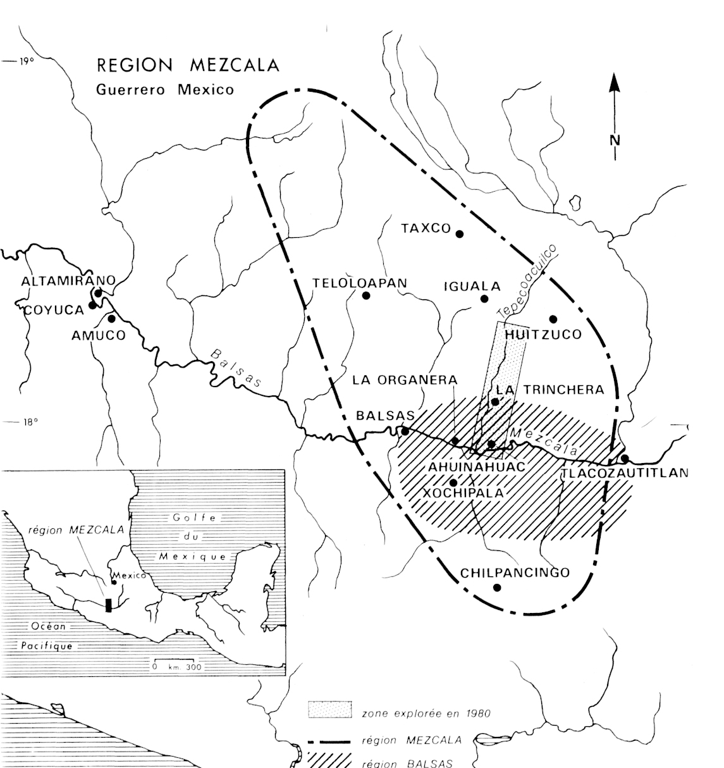

Fig. 5. Map of Guerrero, Mezcala, after http://www.samildan-art.com.

**GPS coordinates**: 17° 55' 00" N, 102° 10' 00" W

Cultural Affiliation: Balsas, Mezcala

Medium: green andesite

Dimensions: H 2.2 in

Weight:

Condition: original

Provenance: from an old collection of Mexican antiques.

**Discussion:**

The definition of the Mezcala styles has been contentious. For instance, Carlo Gay (1967) restricted the Mezcala style to schematic objects dating them to the Preclassic Period. Serra (1973) on the other hand, established another classification focused on anthropomorphic representations.

Ritual re-appropriations of Mezcala votive objects outside the Mezcala area have been found in:

1. Teotihuacan (Rubín de la Borbolla 1964)
2. Xochicalco Valley (Noguera 1961; Sáenz 1961, 1963). A Mezcala anthropomorphic figurine was identified near Xochicalco in association with Tlahuica Polychrome pottery, giving it a date of the Postclassic. Several figurines of the Olmec and Teotihuacan groups of Covarrubias were found in funeral offerings dated from the Classic Period.
3. The great pyramid of Tenochtitlan, Templo Mayor. This was in the heart of the capital of the Aztecs. Although Templo Mayor was destroyed in the 16th century by the Spaniards to make way for massive Christianization of the local populace, Manuel Gamio rediscovered the southwest corner of the pyramid in 1913. Then on 21st February 1978 workers uncovered a 3.1 m stone disc of the Aztec Coyolxauhqui goddess of Darkness.

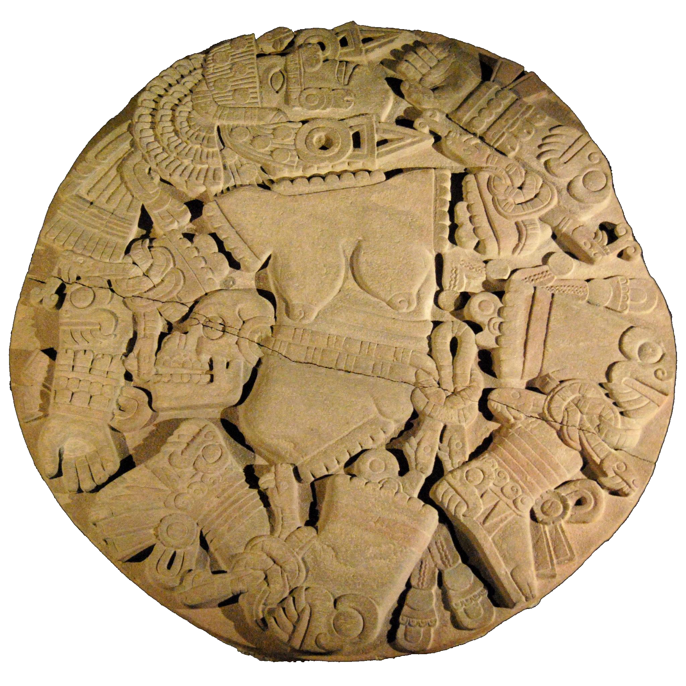

Fig. 6.  3.1 m stone disc of the Aztec Coyolxauhqui goddess of Darkness after http://www.samildan-art.com.

This discovery re-invigorated excavations of the Templo Mayor. These excvations have uncovered may Mezcala figurines that have established it as a repository of Mezcala and other figurines re-appropriated by the Aztecs in their rituals (Batres 1902; Angulo 1966; Contreras 1979; Gonzalez 1986, 1987). Angulo and Contreras in the 1960s described an offering in the structures of the Templo Mayor which contained, among other things, five figurines and five anthropomorphic masks of Chontal style (type 1 of Covarrubias), two masks of type 3 and a small one Model of temple. This offering corresponded to stage IV of the construction of the Templo Mayor. Step IV corresponding to the Recent Postclassic. Gonzalez described thirteen Mezcala offerings in 1978-1980, which were directly associated with the structure of the Templo Mayor. A total of 321 anthropomorphic hard stone figurines were excavated.

- 78 % are clearly linked to the "local" group (Mezcala in the strict sense)

- 17% to the Teotihuacan Group

- 5 % cannot be included in any category

These finds clearly establish the fact that Aztecs were offering Mezcala statuettes to the deities of fertility, especially Tlaloc.

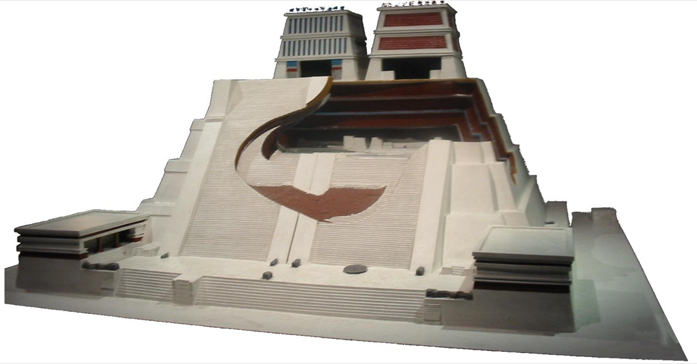

Fig. 7. Model of Templo Mayor with steps that measured 80 m by 90 m at the base, after [http://www.samildan-art.com](http://www.samildan-art.com/).The results of this archaeological reconstruction are exhibited at the [Museo del Templo Mayor](http://www.templomayor.inah.gob.mx/) in the historic center of Mexico City.

The Templo Mayor was built on seven earlier pyramids. Stage I corresponds to the oldest pyramid; stage VII to the most recent pyramid. The Mezcala style statuettes were discovered in Stage IV. It would be contemporaneous with the emperors Moctezuma I and Axayacatl. This corresponds to the recent Postclassic period, ca 1450. This is mainly an extension of the main façade. From this phase remain spectacular elements. There are the great braziers that bear the face of Tlaloc (God of water and fertility). There are others who wear a knot, symbol of Huitzilopochtli (God of war and the sun). We must also add the monumental serpent heads and the bas-relief of the Queen of Darkness. To date 321 anthropomorphic representations have been excavated in Templo Mayor associated with deities of fertility, especially Tlaloc (Gonzalez 1987).

4) Cocula Valley (Early 1986, Cabrera) Discovery of two Mezcala figurines (type 2 of Covarrubias) from a residential structure at the El Mirador site. They were associated with pottery of the Recent Classic.

5) Teopantecuanitlan (Early 1980) Discovery of two Mezcala figurines, made of limestone. They were found on the surface of a structure belonging to the third stage of construction of the site, between 800 and 600 BC. J.C. The proximal presence of a postclassical occupation does not allow to associate them with certainty to the former.

6) Ahuinahuac 1989-1990 Excavation Campaign: 7 Mezcala figures.

The site is two kilometers downstream from the modern village of San Juan Tetelcingo, municipality of Tepecoacuilco, in the State of Guerrero.

Detailed coordinates: 99 ° 32 'West longitude | 17 ° 56 'north latitude.

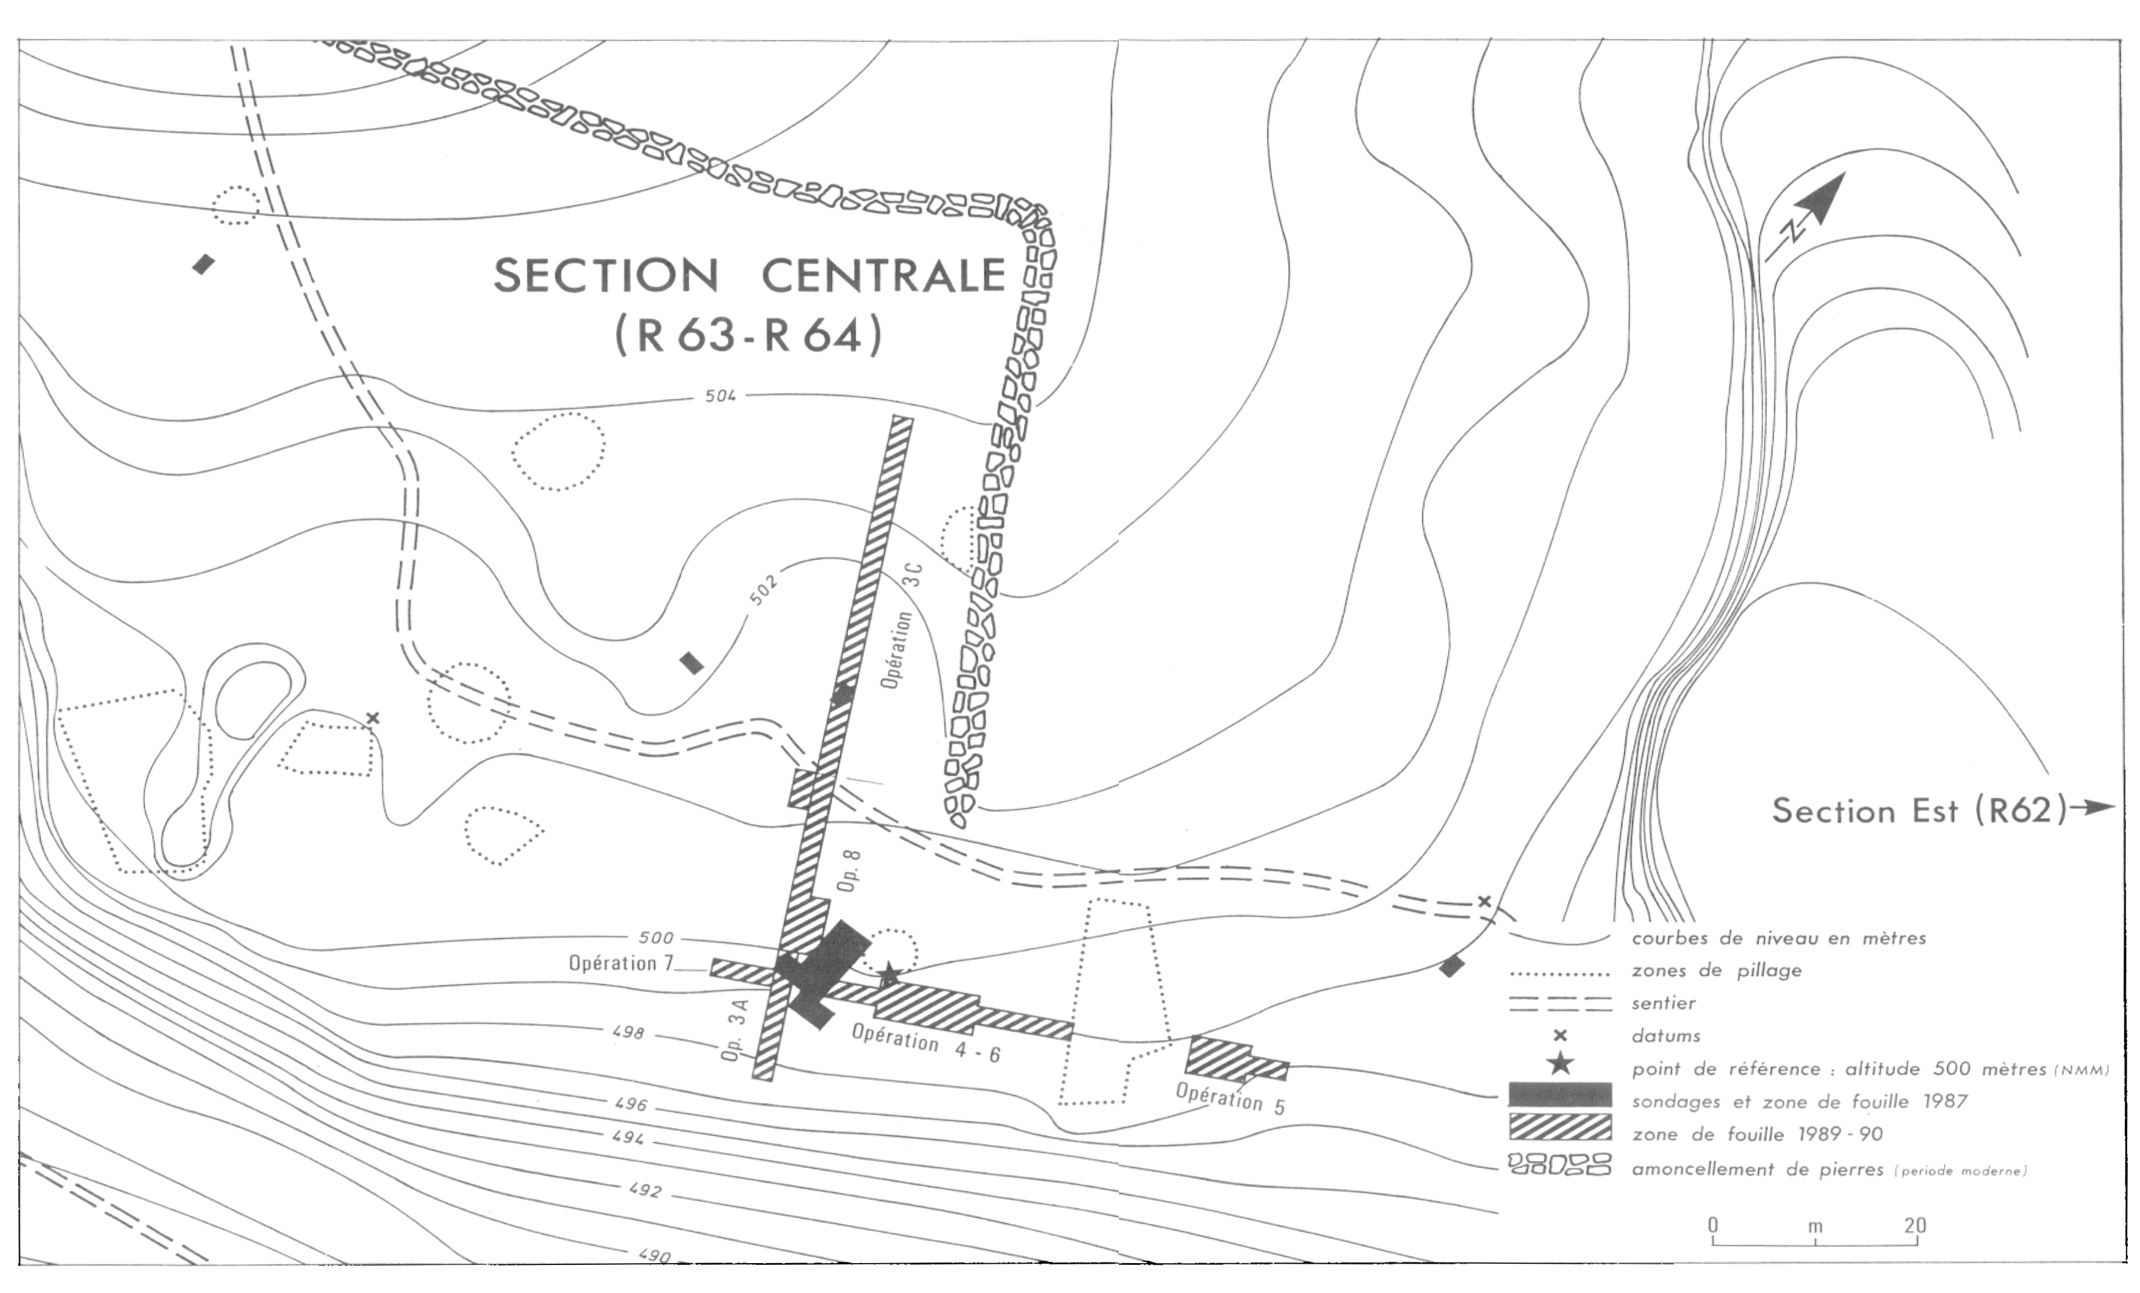

 Fig. 8. Site of Ahuinahuac, after http://www.samildan-art.com.

The site was located during surface surveys carried out in 1980. It has architectural and artefactual remains over its entire surface. The different surface samples show two different occupations, one in the north and the other in the south. The first intention of the archaeologists was to check and document the presence of the Balsas province. The question of its responsibility in the genesis of votive objects Mezcala was underlying. Excavation activities will be concentrated on the central terrace. This terrace of dimension of approximately 200 meters by 200 meters has a relief well flattened. It overlooks the Balsas River by a steep slope of about 15 meters of vertical drop.

Extension of the excavation area of 1987 by two trenches, one along the axis of the terrace and the other perpendicular to the latter, uncovered six of the seven Mezcala objects within a two-meter radius at Operation 6. These pieces consist of four masks and two figures. They are all anthropomorphic and are shaped in a metamorphic stone of a greenish gray marbled with white.  Five pieces: the four masks (3D4, 6D2, 6B1 and 4F1) and the figurine (4G2) form a very homogeneous ensemble. The small figurine (4B1) was distinguished from the others because of its more detailed shaping.

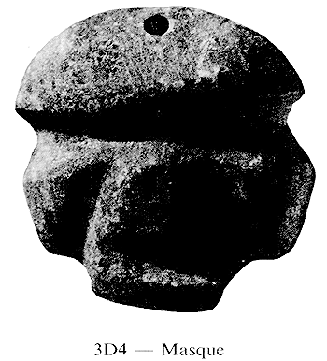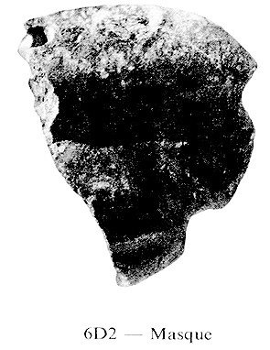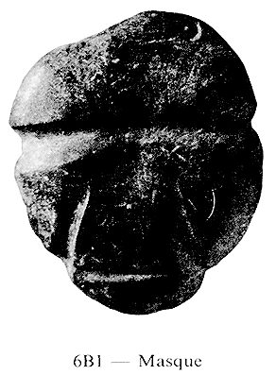

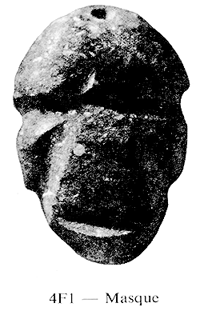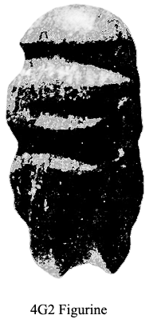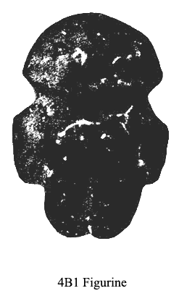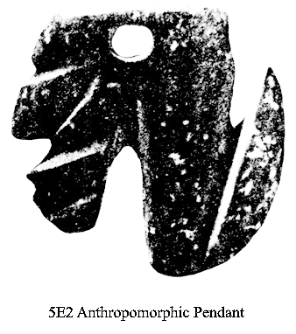

Fig. 9. A-f. Six Mexcala figurines and masks, after http://www.samildan-art.com.

These six Mezcala pieces rested, at various depths, inside a thick embankment associated with the demolition of buildings and redevelopment of the terrace. These stone idols were surely offerings deposited to underline a period of important changes in the history of the site. The seventh Mezcala piece, the squirrel (or monkey), was discovered during Operation 5. It was also in an embankment. Ahuinahuac is important because it is the only controlled Mezcala excavation that allows some level of relative dating. It is located on the right bank of the Balsa River, on alluvial terraces with stone figurines deliberately buried in an embankment that served as the basis for the construction of new housing structures. While is difficult to know the precise motive of this gesture, these offerings were deposited probably during a ritual to consecrate the new housing construction. Similarly, Cabrera Castro identified in El Mirador the association of two Mezcala figurines with a housing structure that may be similar in context to that of Ahuinahuac. Then, at the Ball Court of La Organera-Mezcala, in 1980, Rodriguez discovered a Mezcala type 2 figurine of Covarrubias in the presence of fragments of pottery which chronologically places the find m the Postclassic Period. All of these Mezcala pieces among Aztec ruins are evidence of them being re-appropriated as votive offerings (Paradise et al. 1990).

**References:**

Covarrubias, Miguel, William Spratling, André Emmerich. 1956. *Mezcala, Ancient Mexican Sculpture*. Andre Emmerich Gallery.

Gay, Carlo, Frances Pratt; Gaston Burnand. 1992. *Mezcala-Ancient Stone Sculpture from Guerrero Mexico.* Geneva, Switzerland; Balsas Publications.

Paradise Louise I., Belanger Сhristian, Raby D., Ross B. 1990. “The Mezcala style discovered in context in Guerrero (Mexico)” *Journal of the Society of Americanists*, 76: 199-212.

Reyna Robles, Rosa María. 2003. *La Organera-Xochipala: Un sitio del Epiclásico en la Región Mezcala de Guerrero.* Mexico City, Mexico: Instituto Nacional de Antropología e Historia.

Reyna Robles, Rosa María. 2006. "La Organera-Xochipala, Guerrero," *Arqueología Mexicana*, XIV: 82.

Uzu, Charlotte. 2000. *Les figurines en terre cuite de la région Tepecoacuilco-Balsas Guerrero, Mexique*. [Montréal]: Université de Montréal.

|  |  |  |
| --- | --- | --- |
| [antique Taino Zemi small fetish,hardstone w/ patina caribbean area usa free ship](http://www.ebay.com/itm/172027939917?_trksid=p2057872.m2749.l2649&ssPageName=STRK%3AMEBIDX%3AIT)  ( 172027939917 )  Delivered on Thu, Mar 31  Tracking number: [**Tracking number**9405909699939817329418](javascript:;)  [Add note](javascript:;) | ITEM PRICE:  US $265.00 |  |

|  |  |
| --- | --- |
| ORDER DATEMar 28, 2016 | ORDER TOTAL  US $250.00  + US $60.00  shipping  **Order Taino Zemi Pre Columbian** [Leave feedback - ORDER DATE Mar 28, 2016](http://feedback.ebay.com/ws/eBayISAPI.dll?LeaveFeedbackShow&useridto=artetaino&transactID=0&item=152024056864&_trksid=p2057872.m2749.l2665)[View order details](http://payments.ebay.com/ws/eBayISAPI.dll?ViewPaymentStatus&transId=0&itemid=152024056864&_trksid=p2057872.m2749.l2673) - ORDER DATE Mar 28, 2016  [More actions - ORDER DATE Mar 28, 2016](http://www.ebay.com/myb/PurchaseHistory) |

1 item sold by [artetaino](http://www.ebay.com/usr/artetaino?_trksid=p2057872.m2749.l2754)

[alembix](http://www.ebay.com/usr/alembix?_trksid=p2057872.m2749.l2754), ( 172027939917 ) Mar 28, 2016, Delivered on Thu, Mar 31, [**Tracking number** 9405909699939817329418](javascript:;), ORDER TOTAL US $250.00+ US $60.00 shipping

**OTHER Provenances:**

Binoche and Giquello, archaeological objects from South America. Binoche et Giquello , 5, rue la Boétie - 75008 Paris , Phone : +33 (0)1 47 42 78 01 [www.binocheetgiquello.com](http://www.binocheetgiquello.com/). $1677.

Artcurial 7 Rond-Point des Champs-Élysées 75008 Paris France Phone : +33 (0)1 42 99 20 20 [www.artcurial.com](https://www.artcurial.com/fr/index.asp) E-mail : [contact@artcurial.com](mailto:contact@artcurial.com) $952

